Vision and Values
“To be the best we can be”

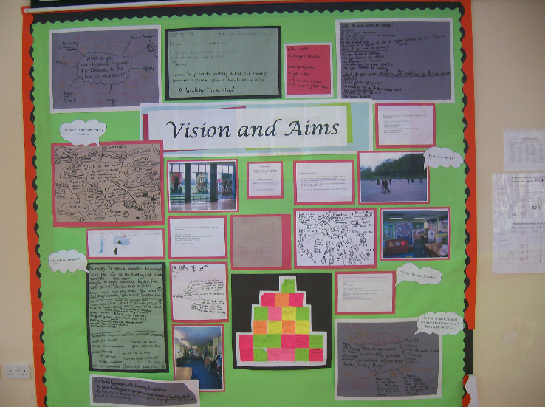

Our School Vision for citizenship now and in the future
We believe that the wellbeing of all members of the school community is at the centre of our life in school and the key to raising academic success. This is supported by high expectations for every child and by developing personal awareness, creativity and social understanding.
We place a strong emphasis on trust, honesty, respect and tolerance through a close partnership between children, staff, governors and parents as an extension to family life. We care about the whole person.
We believe that we make a difference by creating a safe, healthy and stimulating environment of quality provision where our children feel and know how to keep themselves safe, happy and supported in their learning in school and in the wider community.
Our aim is to raise children’s aspirations and to widen their horizons through a context rich curriculum that gives purpose to their learning, offers a range of experiences, as well as broadening understanding of the local, British and global community. We see excellence in teaching and enjoyment in learning as the foundation for success in life. Learning is strongest when those involved with learning commit energy, focus on a real goal, do not give up and work hard to overcome obstacles.
Above all, we aim to develop positive, confident, reflective children who
- take part in decision making within the classroom and school so that they have sound knowledge of their own value and purpose
- Understand the school rules and those of society so that they can make choices and decisions for themselves with the understanding of what is right and wrong
- are able to think creatively and independently in order to have aspirations for the future
- are proud to be part of a diverse British society

